How to make Internet Explorer 10 run in compatibility mode
By Ajay Balachandran
November 9, 2012

I know it might come as a surprise to many of you, but Internet Explorer 10 is AWESOME. It is the fastest and the most standards compliant version of the most hated browser in the world.
I always think if Microsoft had done this about 3 years ago it would have been the most popular browser in the world.
Now getting to the point, if you are a web developer or designer like me and are using Windows 8 and find that your latest work is being rendered properly in your version of Internet Explorer but not on your client’s ridiculously old IE7, and are sitting helpless , thinking of rolling back to Windows XP just for this reason, then worry not, this tutorial is for you !
1. Open up Internet Explorer 10 (The non metro version. I still haven’t tested with the metro version).
2. Press ‘Alt’ key on your keyboard to bring up the top menu. And then go to Tools > Developer Tools. Alternatively you can just press the ‘F12’ key on your keyboard.
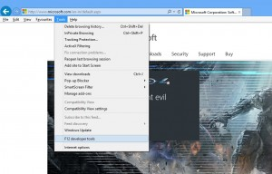
3. This will bring up the IE developer tools which looks just like the one in Google Chrome at the bottom.
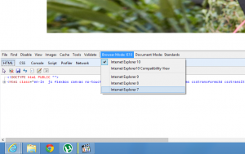
Web Developer Tools in Internet Explorer 10
You can then click ‘Browser Mode’ and then click on the Internet Explorer version you want to simulate (IE9). You can also set the document mode to quirks mode or standards mode from the next drop down .

