IE 10 & 11 Compatibility Settings

Microsoft began pushing the Internet Explorer 11.0 update through Windows Updates on November 7th, 2013.

Qualifacts has not completed testing and certification of CareLogic use with Internet Explorer 10 or 11.0.

If your PC has been upgraded to either Internet Explorer 10 or 11.0 you may experience issues logging into CareLogic.

If you login and receive a blank white screen (IE10) or receive the error message “In order to access your account, Internet Explorer must be used" you will need to put your system in Compatibility View.

Please follow these steps to put your system in Compatibility View:

1) In Internet Explorer, click on Tools

NOTE: If you do not see the menu links for File/Edit/View/Favorites/Tools/Help as shown in the screen shot below hit your ALT key on the keyboard to bring it up.

2) Click Compatibility View Settings
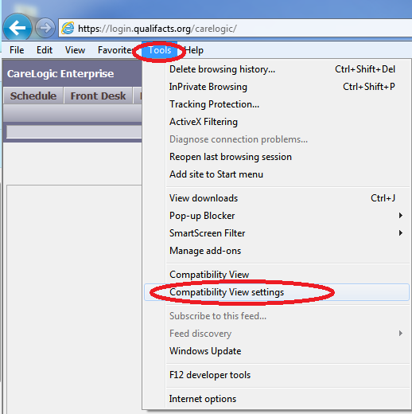

3) You will be presented with the Compatibility View Settings window shown below.

4) Ensure qualifacts.org is listed in the “Add this Website” box

5) Click the Add button
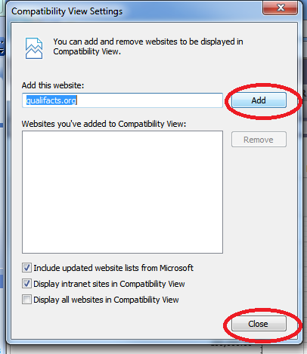
6) Click the close button

This should take you back to the CareLogic login screen. Go ahead and attempt to login to CareLogic again. You should be able to login and navigate the system normally.

If, after attempting these steps you are still unable to login please submit an EHR Zendesk trouble ticket for assistance.

